It is relation between entity classes(Example:a&b). where one instance of entity class-a can be associated with multiple instances of entity class-b and one instance of entity class-b can also be associated with multiple instances of entity class-a.

Example: Multiple students will join in multiple courses.

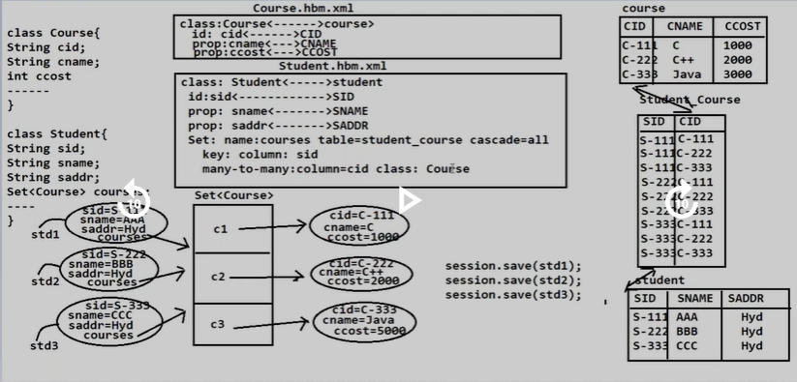

**Example:1 Using xml tags.**

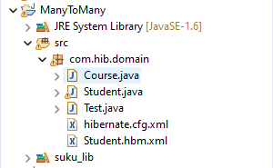

**Domain classes:**

**1.Student.java**

**package** com.hib.domain;

**import** java.io.Serializable;

**import** java.util.Set;

**public** **class** Student **implements** Serializable {

**private** **int** sid;

**private** String sname;

**private** String saddr;

**private** Set<Course> cour;

**public** **int** getSid() {

**return** sid;

}

**public** **void** setSid(**int** sid) {

**this**.sid = sid;

}

**public** String getSname() {

**return** sname;

}

**public** **void** setSname(String sname) {

**this**.sname = sname;

}

**public** String getSaddr() {

**return** saddr;

}

**public** **void** setSaddr(String saddr) {

**this**.saddr = saddr;

}

**public** Set<Course> getCour() {

**return** cour;

}

**public** **void** setCour(Set<Course> cour) {

**this**.cour = cour;

}

}

**2.Course .java**

**package** com.hib.domain;

**public** **class** Course {

**private** **int** cid;

**private** String cname;

**public** **int** getCid() {

**return** cid;

}

**public** **void** setCid(**int** cid) {

**this**.cid = cid;

}

**public** String getCname() {

**return** cname;

}

**public** **void** setCname(String cname) {

**this**.cname = cname;

}

}

**Hibernate Mapping File:Student.hbm.xml**

<?xml version=*"1.0"* encoding=*"UTF-8"*?>

<!DOCTYPE hibernate-mapping PUBLIC

"-//Hibernate/Hibernate Mapping DTD 3.0//EN"

"http://www.hibernate.org/dtd/hibernate-mapping-3.0.dtd">

<hibernate-mapping>

<class name=*"com.hib.domain.Student"* table=*"student"*>

<id name=*"sid"* column=*"sid"* length=*"10"*/>

<property name=*"sname"* column=*"sname"* length=*"10"*/>

<property name=*"saddr"* column=*"saddr"* length=*"10"*/>

<set name=*"cour"* table=*"stu_cour"* cascade=*"all"*>

<key column=*"sid"*></key>

<many-to-many column=*"cid"* class=*"com.hib.domain.Course"*/>

</set>

</class>

<class name=*"com.hib.domain.Course"* table=*"course"*>

<id name=*"cid"* column=*"cid"* length=*"10"*/>

<property name=*"cname"* column=*"cname"* length=*"10"*/>

</class>

</hibernate-mapping>

**Hibernate Configuration file**

<?xml version=*"1.0"* encoding=*"UTF-8"*?>

<!DOCTYPE hibernate-configuration PUBLIC

"-//Hibernate/Hibernate Configuration DTD 3.0//EN"

"http://www.hibernate.org/dtd/hibernate-configuration-3.0.dtd">

<hibernate-configuration>

<session-factory>

<property name=*"hibernate.connection.driver_class"*>oracle.jdbc.OracleDriver</property>

<property name=*"hibernate.connection.url"*>jdbc:oracle:thin:@localhost:1521:xe</property>

<property name=*"hibernate.connection.username"*>system</property>

<property name=*"hibernate.connection.password"*>tiger</property>

<property name=*"hibernate.dialect"*>org.hibernate.dialect.OracleDialect</property>

<property name=*"show_sql"*>true</property>

<property name=*"hibernate.hbm2ddl.auto"*>create</property>

<mapping resource=*"com/hib/domain/Student.hbm.xml"*/>

</session-factory>

</hibernate-configuration>

**ClientApplication:Test.java**

**package** com.hib.domain;

**import** java.util.HashSet;

**import** java.util.Set;

**import** org.hibernate.Session;

**import** org.hibernate.SessionFactory;

**import** org.hibernate.Transaction;

**import** org.hibernate.cfg.Configuration;

**public** **class** Test {

**public** **static** **void** main(String[] args) {

Configuration cfg=**new** Configuration();

cfg.configure("com/hib/domain/hibernate.cfg.xml");

SessionFactory sf=cfg.buildSessionFactory();

Session s=sf.openSession();

Transaction t=s.beginTransaction();

Student s1=**new** Student();

Course c1=**new** Course();

Course c2=**new** Course();

s1.setSid(1);

s1.setSname("suku");

s1.setSaddr("nlr");

c1.setCid(7);

c1.setCname("MCA");

c2.setCid(8);

c2.setCname("MBA");

Set<Course>sd=**new** HashSet<Course>();

sd.add(c1);

sd.add(c2);

s1.setCour(sd);

**int** pk=(Integer)s.save(s1);

**if**(pk==1) {

t.commit();

System.***out***.println("Record Inserted");

}

**else**

{

System.***out***.println("Record Not Inserted");

}

}

}

**Output:**

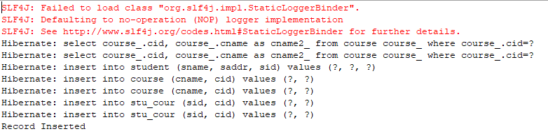

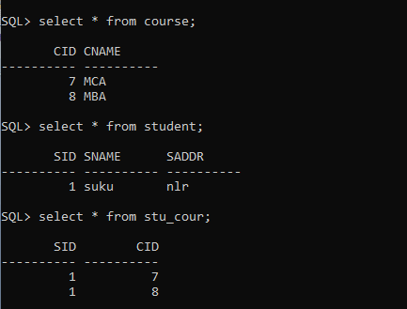

**Example: using annotations.**

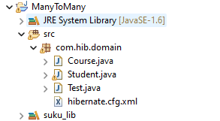

**Annotated classes**

**1.Student.java**

**package** com.hib.domain;

**import** java.io.Serializable;

**import** java.util.Set;

**import** javax.persistence.CascadeType;

**import** javax.persistence.Column;

**import** javax.persistence.Entity;

**import** javax.persistence.Id;

**import** javax.persistence.JoinColumn;

**import** javax.persistence.JoinTable;

**import** javax.persistence.ManyToMany;

**import** javax.persistence.Table;

@Entity

@Table(name="student")

**public** **class** Student **implements** Serializable {

@Id

@Column(name="sid",length=10)

**private** **int** sid;

@Column(name="sname",length=10)

**private** String sname;

@Column(name="saddr",length=10)

**private** String saddr;

@ManyToMany(cascade=CascadeType.***ALL***)

@JoinTable(name="stu_cour" ,joinColumns= {@JoinColumn(name="sid")},inverseJoinColumns= {@JoinColumn(name="cid")})

**private** Set<Course> cour;

**public** **int** getSid() {

**return** sid;

}

**public** **void** setSid(**int** sid) {

**this**.sid = sid;

}

**public** String getSname() {

**return** sname;

}

**public** **void** setSname(String sname) {

**this**.sname = sname;

}

**public** String getSaddr() {

**return** saddr;

}

**public** **void** setSaddr(String saddr) {

**this**.saddr = saddr;

}

**public** Set<Course> getCour() {

**return** cour;

}

**public** **void** setCour(Set<Course> cour) {

**this**.cour = cour;

}

}

**2.Course.java**

**package** com.hib.domain;

**import** javax.persistence.Column;

**import** javax.persistence.Entity;

**import** javax.persistence.Id;

**import** javax.persistence.Table;

@Entity

@Table(name="course")

**public** **class** Course {

@Id

@Column(name="cid",length=10)

**private** **int** cid;

@Column(name="cname",length=10)

**private** String cname;

**public** **int** getCid() {

**return** cid;

}

**public** **void** setCid(**int** cid) {

**this**.cid = cid;

}

**public** String getCname() {

**return** cname;

}

**public** **void** setCname(String cname) {

**this**.cname = cname;

}

}

**HibernateConfigurationfile:hibernate.cfg.xml**

<?xml version=*"1.0"* encoding=*"UTF-8"*?>

<!DOCTYPE hibernate-configuration PUBLIC

"-//Hibernate/Hibernate Configuration DTD 3.0//EN"

"http://www.hibernate.org/dtd/hibernate-configuration-3.0.dtd">

<hibernate-configuration>

<session-factory>

<property name=*"hibernate.connection.driver_class"*>oracle.jdbc.OracleDriver</property>

<property name=*"hibernate.connection.url"*>jdbc:oracle:thin:@localhost:1521:xe</property>

<property name=*"hibernate.connection.username"*>system</property>

<property name=*"hibernate.connection.password"*>tiger</property>

<property name=*"hibernate.dialect"*>org.hibernate.dialect.OracleDialect</property>

<property name=*"show_sql"*>true</property>

<property name=*"hibernate.hbm2ddl.auto"*>create</property>

<mapping class=*"com.hib.domain.Student"*/>

<mapping class=*"com.hib.domain.Course"*/>

</session-factory>

</hibernate-configuration>

**ClientApplication:Test.java**

**package** com.hib.domain;

**import** java.util.HashSet;

**import** java.util.Set;

**import** org.hibernate.Session;

**import** org.hibernate.SessionFactory;

**import** org.hibernate.Transaction;

**import** org.hibernate.cfg.Configuration;

**public** **class** Test {

**public** **static** **void** main(String[] args) {

Configuration cfg=**new** Configuration();

cfg.configure("com/hib/domain/hibernate.cfg.xml");

SessionFactory sf=cfg.buildSessionFactory();

Session s=sf.openSession();

Transaction t=s.beginTransaction();

Student s1=**new** Student();

Course c1=**new** Course();

Course c2=**new** Course();

s1.setSid(1);

s1.setSname("suku");

s1.setSaddr("nlr");

c1.setCid(7);

c1.setCname("MCA");

c2.setCid(8);

c2.setCname("MBA");

Set<Course>sd=**new** HashSet<Course>();

sd.add(c1);

sd.add(c2);

s1.setCour(sd);

**int** pk=(Integer)s.save(s1);

**if**(pk==1) {

t.commit();

System.***out***.println("Record Inserted");

}

**else**

{

System.***out***.println("Record Not Inserted");

}

}

}

**Output:-**

